# Student Activities Management System

Project Documentation Submitted

To the Faculty of School of

Computer Science and Information Technology

Of

Asia Pacific College

In Partial Fulfillment of the Requirements for the subject

Applied Projects 2 or Software Development

By

John Kenneth Ferrer

Chamber Jose

Rempson Dulitin

**Table of Contents**

Page no

Project Title 1

I. Narrative 3

A. Executive Summary 3

B. Introduction 3

1. Client Profile 3

2. Project Organization 3

a. Project Team 3

b. Project Professor 3

c. Project Adviser(s) 3

3. Client’s Mission and Objectives 3

4. Project Objectives 3

5. Purpose of the Project 3

6. Rationale of the Project 3

a. The Current Process Flow 3

b. User Information Needs 3

c. How the Information is being processed 3

C. Systems Features and Functions 3

1. Software Environment 4

a. Programming Languages 4

b. Specific Software 4

c. Web Server Application 4

d. Operating System 4

e. Other Software 4

2. Hardware Environment 4

3. Networking and Security 4

a. Security 4

b. Server 4

4. Application System Modules 4

a. 4

b. 4

c. 4

d. 4

II. System Diagrams and Screenshots 4

A. Data Flow Diagrams 4

1. Context Level Data Flow Diagram 4

2. Level 0 Data Flow Diagram 4

B. UML Diagrams 4

C. Entity – Relationship Diagram 5

D. Data Dictionary 5

E. Screenshots 5

F. Lessons Learn 5

III. Appendices 5

# Narrative

## Executive Summary

The APC Student's Activities Office (SAO), in cooperation with different extra-curricular organizations in Asia Pacific College (APC), handle various transactions such as re/accreditation, financing, event handling and much more. because of the use of outdated technology and old school methods, transactions among SAO and the officers of extra-curricular organizations seemed to be inefficient concerning time management and lack of collaboration.

With the Organization's need for a better solution, the Project Team has grabbed the opportunity to work with APC SAO to develop a system called Student Activities Management System. The Student Activities Management System is a Project that aims to enhance the collaboration between the Student Activities Office (SAO) and the different organizations within Asia Pacific College (APC). Moreover, this will help in reduction of workloads and solve problems which are most of the time, due to the use of large volumes of papers and manual methods of document processing for every transaction the office is doing.

## Introduction

### Client Profile

The **Student Activities Office**, headed by the Student Activities Officer, supervises the co- and extra-curricular activities of students. This office issues and acts upon required application forms for holding off- or on-campus activities.

### Project Organization

### Project Team

|  |  |  |
| --- | --- | --- |
| Name | Position | E-Mail |
| Ferrer, John Kenneth H. | Project Manager | [jhferrer@student.apc.edu.ph](mailto:jhferrer@student.apc.edu.ph) |
| Jose, Chamber F. | Project Developer | [cfjose@student.apc.edu.ph](mailto:cfjose@student.apc.edu.ph) |
| Dulitin, Rempson P. | Project Developer | [rpdulitin@student.apc.edu.ph](mailto:rpdulitin@student.apc.edu.ph) |

### Project Professor

|  |  |  |
| --- | --- | --- |
| Name | Position | E-Mail |
| Mr. Manuel Sebastian S. Sanchez | Professor | [manuels@apc.edu.ph](mailto:manuels@apc.edu.ph) |

### Project Adviser(s)

|  |  |  |
| --- | --- | --- |
| Name | Position | E-Mail |
| Mr. Jacob Catayoc | Adviser | [jacobc@apc.edu.ph](mailto:jacobc@apc.edu.ph) |

### Client’s Mission and Objectives

The mission of the SAO is to work in partnership with the academic mission of the College, undertaking worthwhile activities that will help develop well-rounded students.

### Project Objectives

#### General Objectives

* To develop collaboration between the Office Directors and Organizations' Representative/s
* To be able to promote the use of newer technology to lessen paper works and other workloads

### Specific Objectives

* To provide the Student's Activities Office (SAO), a Document Library Management System, an efficient way to handle document transactions and event handling operations

### Purpose of the Project

The purpose of the project is to provide the SAO a Document Library Management System to make their work efficient. It will make the transaction or process of the activities easier and effective for the users. It will help them organize the documents needed to able to process an event or accomplishment. Therefore, this project will only provide what the clients need to able to eliminate the manual process of the documents.

### Rationale of the Project

### The Current Process Flow

The manual process of the APC Student Activities Office of managing its transactions seemed to cause a lot of problems to the department such as human error, missing documents and more. Because of the involvement of use of papers in document processing, the department used to consume a lot of time for doing just a single task which reduces its productivity and work efficiency.

### User Information Needs

### How the Information is being processed

The information sent to the APC Students Activities Office are being processed in a procedural approach which means to say that an information that is passed in one department will go through the other agencies in which the department is related to.

Using document approval processing as an example, in the existing process, the transaction will start once an organization representative has requested a document form (i.e., Activity Proposal form). The SAO head will print the requested form which will be filled in by the organization and will be sent back to the office for approval. Once a document has been submitted, the SAO head will send the document to the Student Affairs Head and wait for its approval. Once a document has been approved, the SAO head are always expected to approve the document and remind the organization of the approval status. Otherwise, if its disapproved, the SAO head will automatically disapprove the document as well

With the integration of the Student Activities Management System, some of the process of the department are expected to be automated and more secured than the older process. Using the aforementioned example to describe the manual process of document transaction, the Student Activities Office head will post a document form in its page, granting its users the access to download and edit those documents. Once a document has been downloaded and filled in by an organization representative, specifically, the Organization's President or VP, the document should be uploaded again to the system, which will be stored in the organization's document repository. The SAO head will request for access to the requested document, and the organization is expected to grant document access to the SAO Head for approval.

## Systems Features and Functions

### Software Environment

### Programming Languages

* + - PHP
    - MySQL

### Specific Software

* + - Cobalt Framework
    - Internet Browser (IE, Edge, Mozilla Firefox, Chrome, etc.)
    - Notepad++ or any PHP IDE
    - MySQL Workbench CE 6.3

### Web Server Application

* + - XAMPP Control Panel
    - IBM Bluemix

### Operating System

* + - Microsoft Windows 8.1 or Later

### Other Software

### Hardware Environment

### Networking and Security

The framework environment that the developers has used to create the system already had its own security implementations in different fields of operation in the system such as password, system and access and performance security. Each of this fields will be discussed on how these security implementations are applied into the system

* **Password Security** - By the time a user signs up for an account, the system will hash the entered password with different random algorithms and ensures that it will be as complex as it is
* **System and Access Security** - The system has an Access Control List (ACL) which is responsible for managing each user's privileges based on the user role assigned to them. Once a user tried to access a module which is not part of their access, the user will be blocked from accessing that page, and a report will be created to be sent to system admin for analysis
* **Performance Security** - The system has a feature called the "Cobalt Supersonic Self-testing" feature. This feature will help to diagnose if the system modules / entire system is still working at its best which therefore promotes the prevention of system errors and other technical problems

### Application System Modules

**a. Reset Password Module**

**b. Sign-up Module**

**c. Login Module**

**d. UI Skin Change Module**

**e. Forgot Password Module**

**f. Documents Module**

**g. Calendar Module**

**h. Document Requests Module**

**i. Organization Profile Module**

### 

# System Diagrams and Screenshots

## Data Flow Diagrams

### Context Level Data Flow Diagram

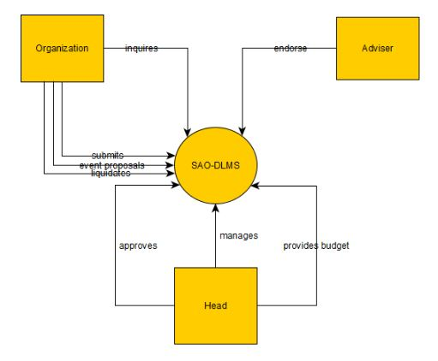

### Level 0 Data Flow Diagram

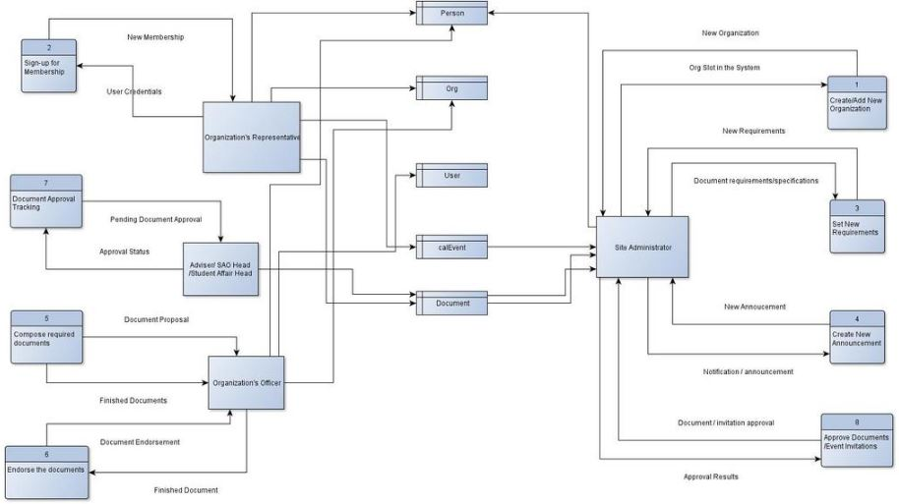

## UML Diagrams

**Communication Diagram**

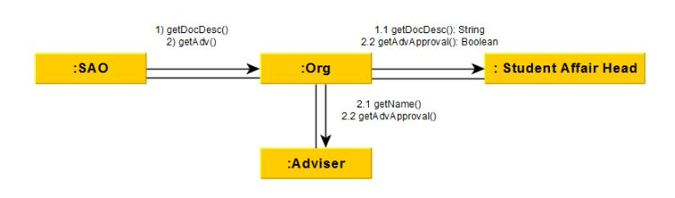

**Object Diagram**

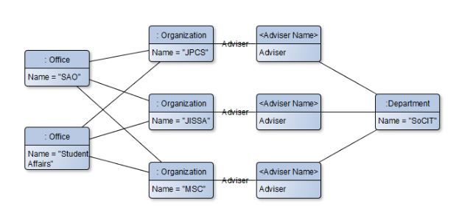

**State Machine Diagram**

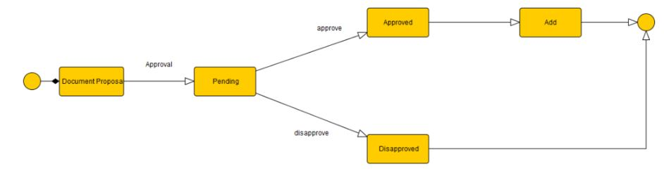

**Timing Diagram**

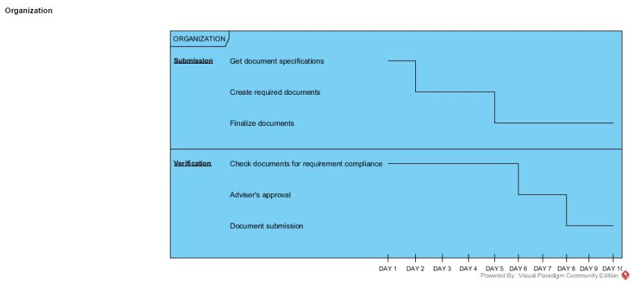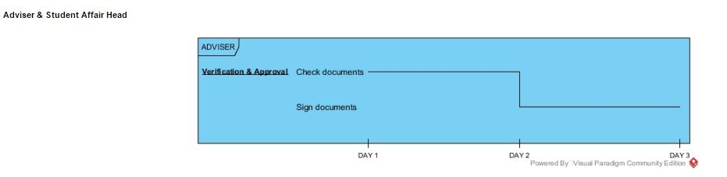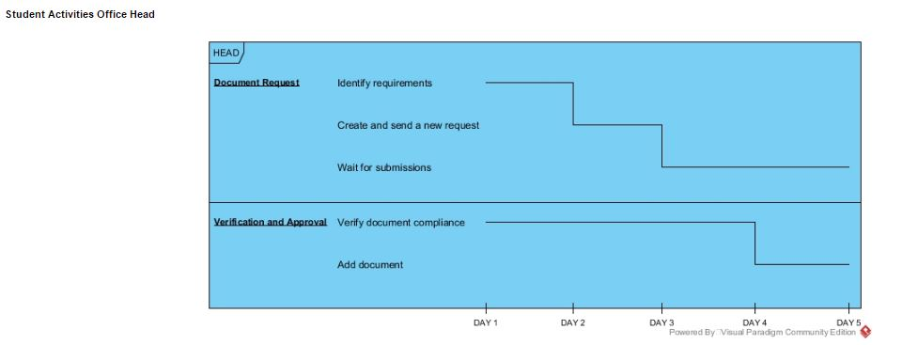

**Class Diagram**

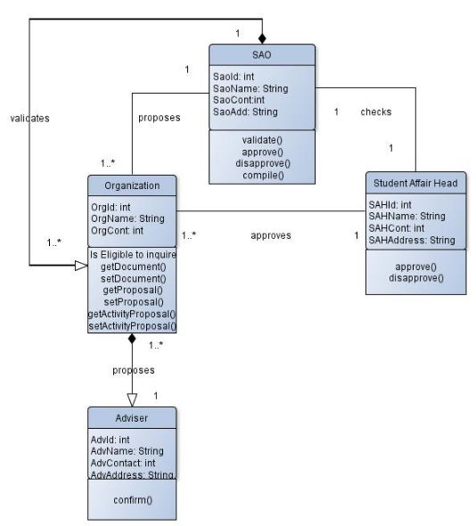

**Sequence Diagram**

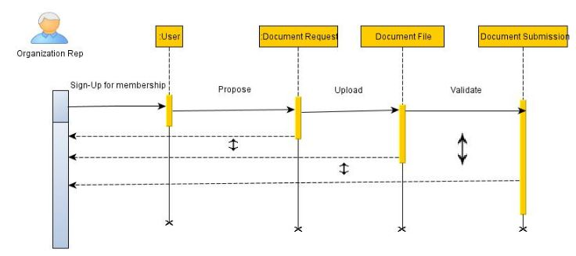

**Package Diagram**

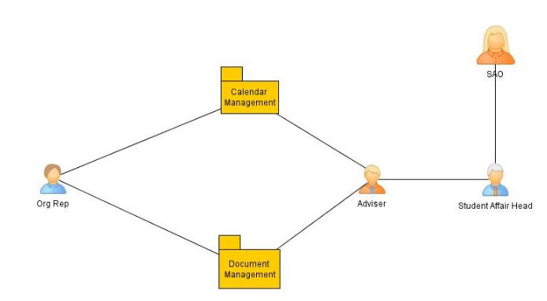

**Deployment Diagram**

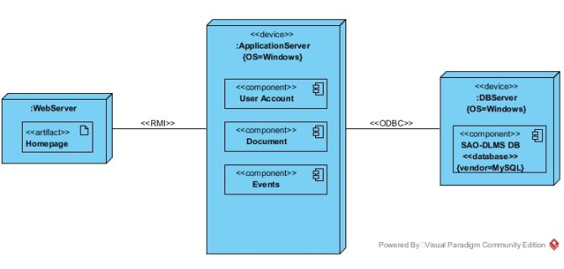

**Activity Diagram**

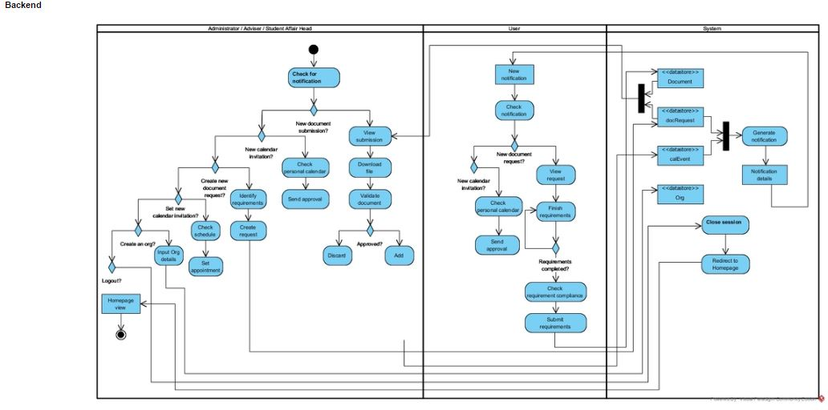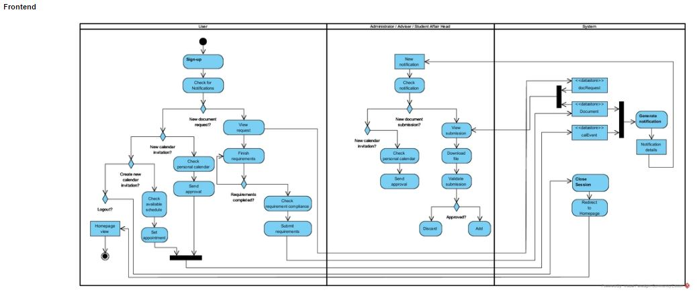

**Component Diagram**

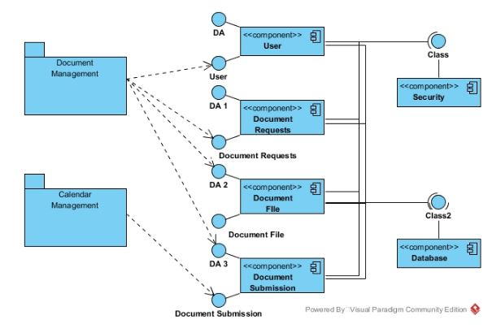

**Composite Structure Diagram**

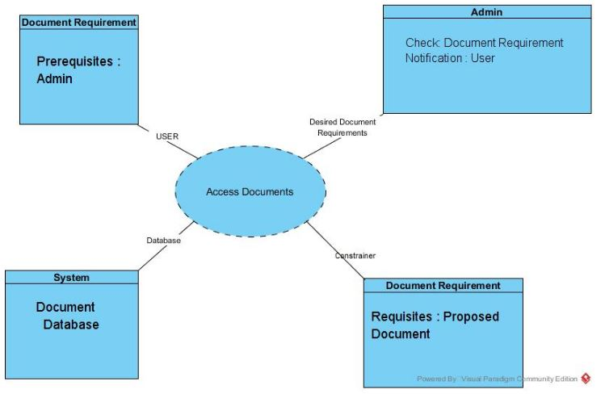

**Interaction Overview Diagram**

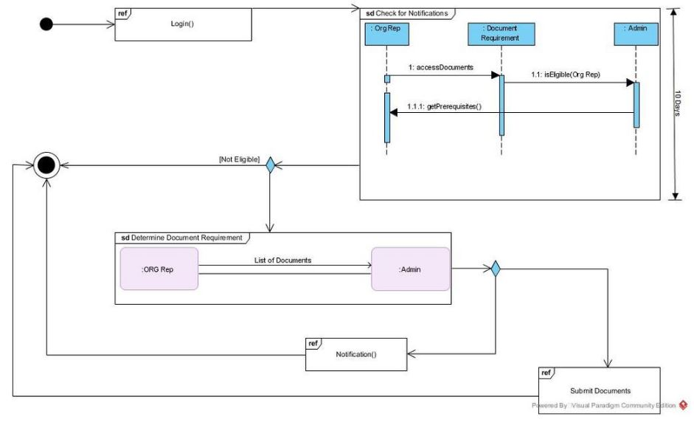

## Entity – Relationship Diagram

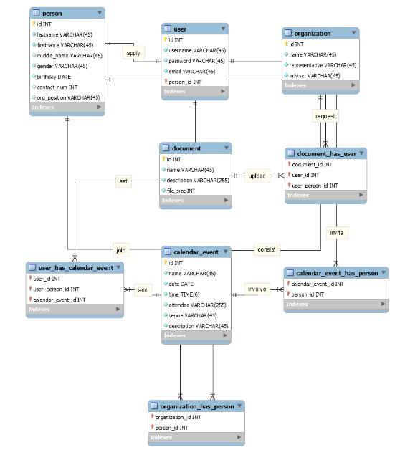

## Data Dictionary

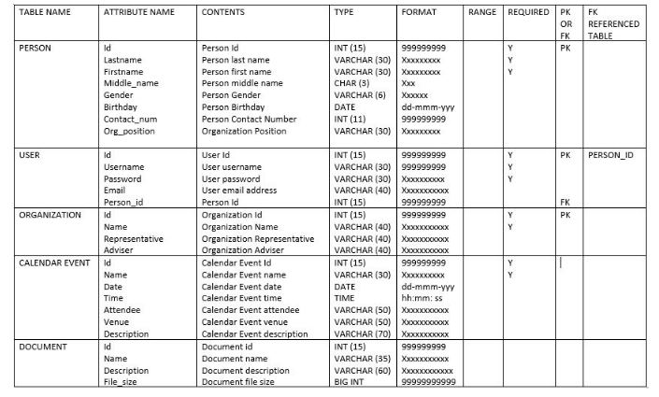

## Screenshots

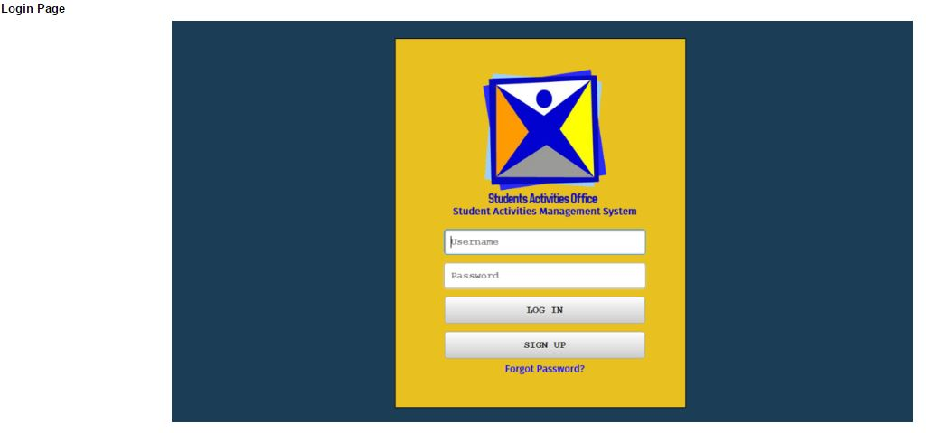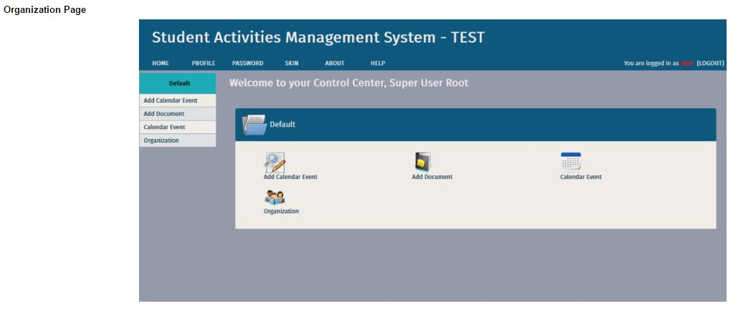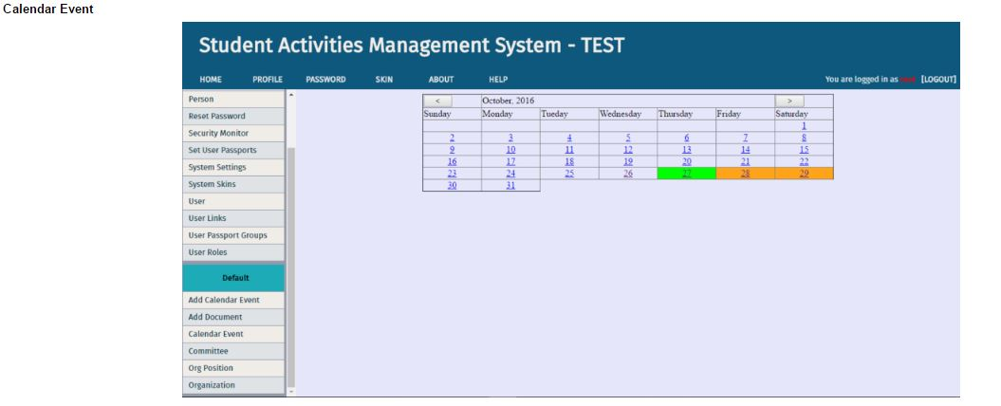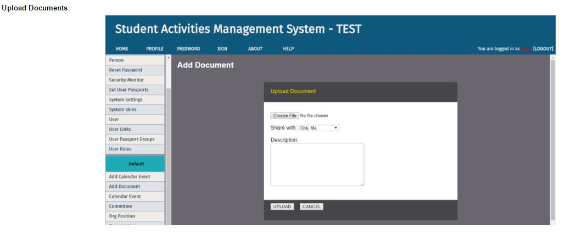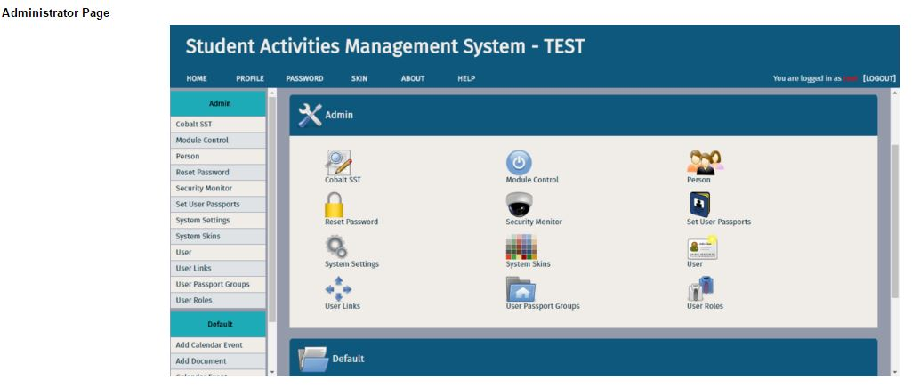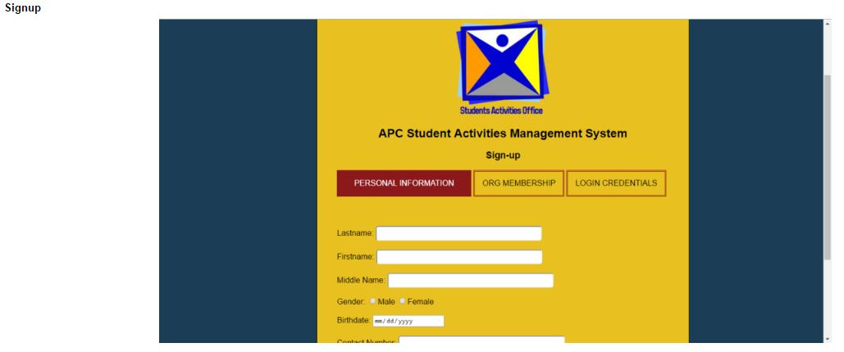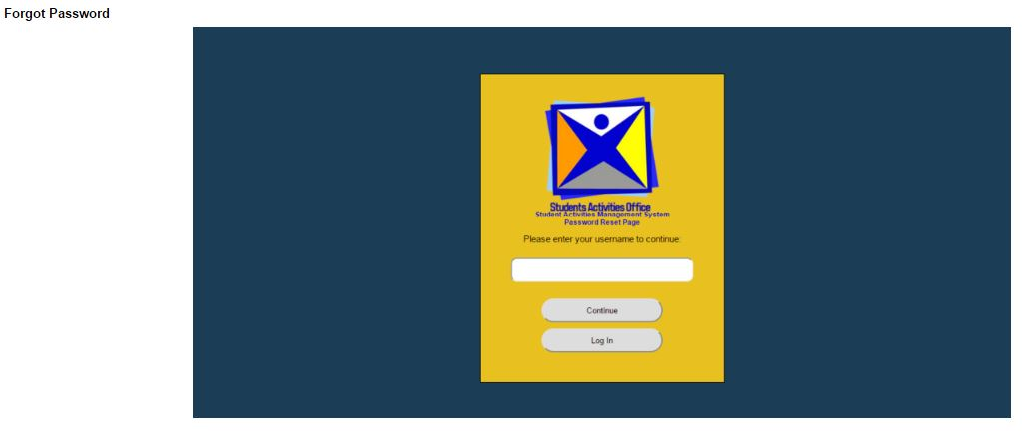

## Lessons Learn

# Appendices